Year 4 Parent Information
Summer Term 1
Year 4 Staff
Monday – Wednesday: Miss Webb
Wednesday – Friday: Mrs Farrier
Mrs Maddison and Miss Trowbridge

Homework
Please can you ensure that children complete:
• 10 minutes reading every day. Books and records to be handed in every day. Books to be changed flexibly. Please ask comprehension questions whilst reading with your children at home. Examples of these are on our class page in the form of a printable bookmark to keep in your reading book.
• Grammar set on Rollama weekly.
• Spellings set on Spelling Shed weekly.
• Tomes table homework grid (if you have misplaced this let us know and we can send home a new copy)
• Optional Homework grid

Ancient Civilisations
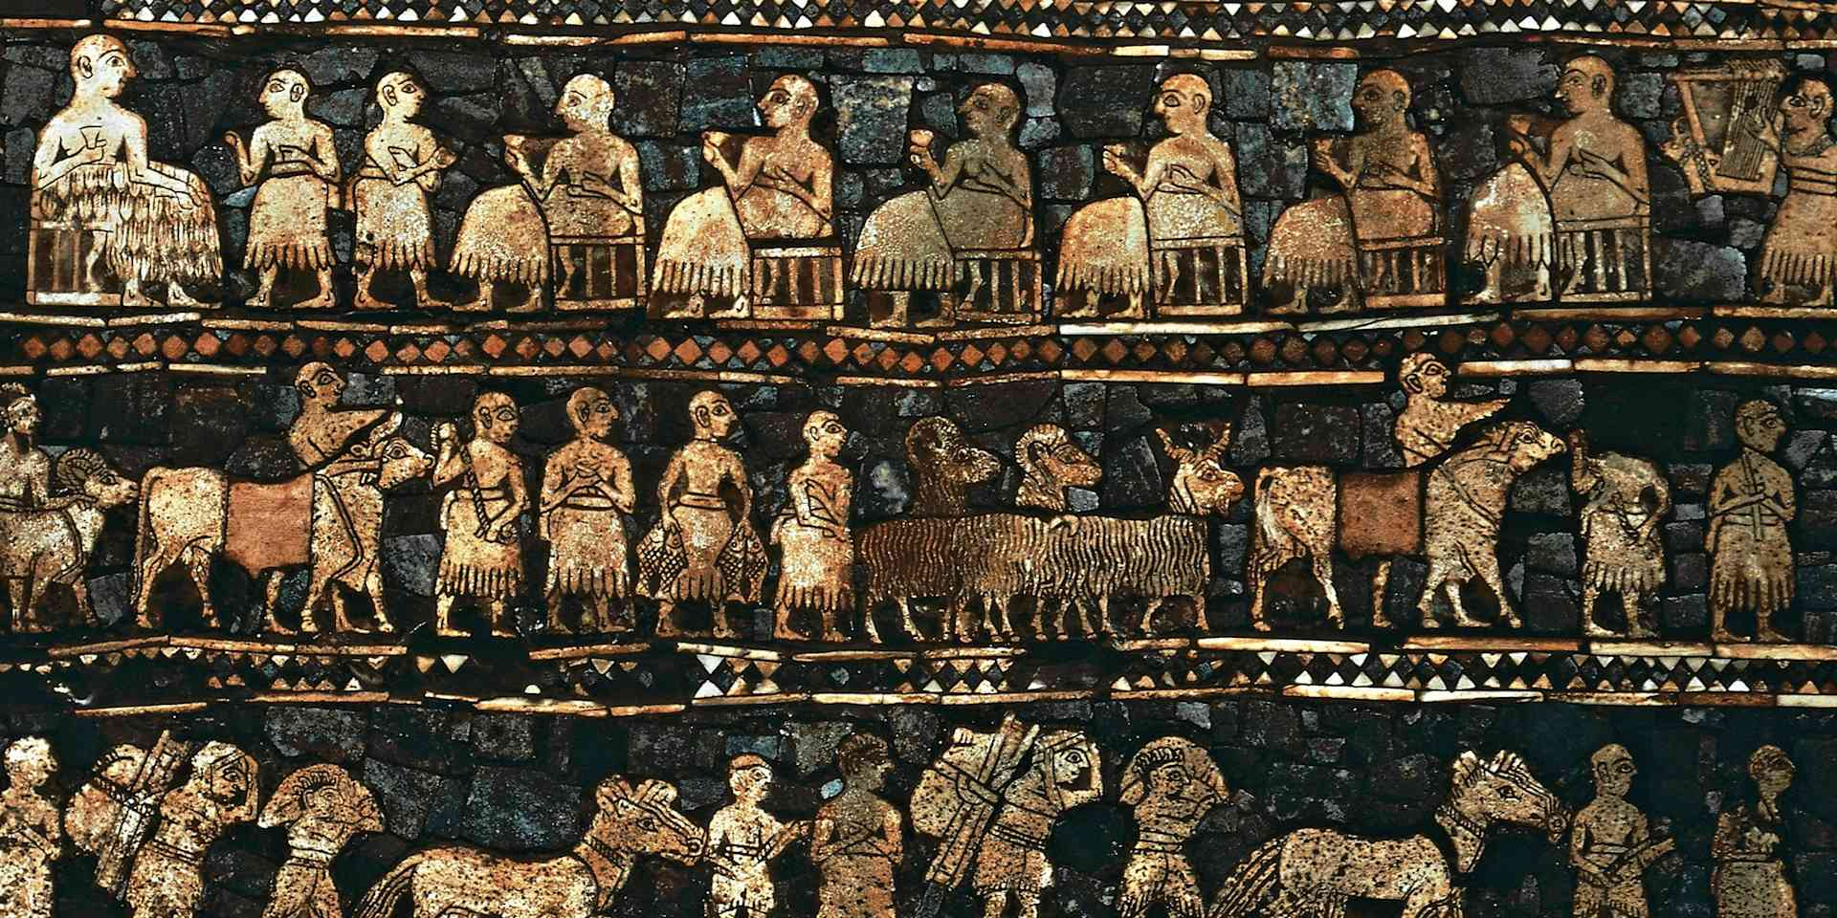
Part 1
Literacy: In our writing sessions, we will be using the book ‘The Journey’ by Francesca Sanna. We will be focusing on some key skills from Year 4 including direct speech, extending fronted adverbials of manner and using past perfect tense. Our end of unit aims will be writing an innovated story inspired by our book and a letter from the viewpoint of a refugee. We will also be exploring performance poetry and write some short poems to perform.
Maths: We will be starting with our fraction unit this term. We will be learning about mixed numbers and improper fractions and how to convert between the two. We will finish our fractions unit by adding and subtracting fractions. We will then start our first decimals unit, which will begin with looking at tenths and hundredths before moving on to dividing one and two digit numbers by 10 or 100.
Science: This term we will be learning about electrical circuits and conductors. This will teach children about electrical appliances and safety. They will be constructing simple series circuits and naming their parts and functions, including switches, wires and cells. They will investigate electrical conductors and insulators and identify common features of conductors.
PE: PE will continue to be on a Monday and Thursday.
We are lucky enough to have cricket coaches come in some Monday mornings this term to teach cricket skills. On Thursday afternoons, we will starting our Athletics unit. PE kit consists of your child’s coloured house t-shirt and shorts or jogging bottoms in black or navy.
History: We will be starting our ‘Ancient Civilisations’ unit focusing on learning more about the Ancient Sumer civilisation. We will be learning about the development of the Ancient Sumer civilisation and how their lived. Looking at areas including food, farming and hierarchy.
Art and D&T: This term we are focusing on art, the topic is about statues, statuettes and figurines. We will begin by exploring a range of artists who use human figures within their work. We will expand upon this and explore ancient sculpture before making Sumer-style figurines.
PSHE: On Monday mrnings, we will complete our final My Happy Mind module: Engage. This will focus on n bringing together everything the children have learnt in My Happy Mind lessons this year. It has a particular focus on using the knowledge and skills they have acquired to help them engage in the world through Goal Setting. We will also complete some PSHE work on keeping safe.
Music: This term, we will be focusing our learning on the classic Beatles song ‘Blackbird’. This will include our core skills of listening and appraising, as well as performing and composing.

