Force Detective – Find 5 examples of pushes, pulls, gravity or friction around your home. Explain which force is acting and why  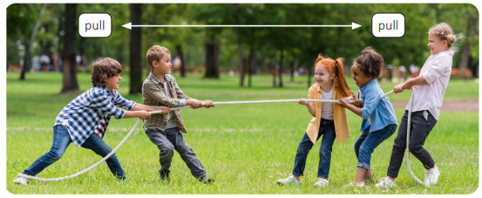 | Character Detective – Describe a character using evidence from your book. Include at least three quotations or examples | Geography – Comparing Two Settlements  Settlement Comparison – Compare your local area with another settlement (village, town or city). Create a table showing similarities and differences.
Simple Machines Hunt  Find examples of levers, pulleys, gears or wheels and axles. Draw them and explain how they make work easier.  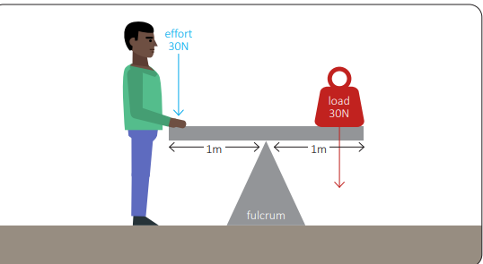 | Prediction – Read halfway through a chapter. Predict what will happen next and explain which clues helped you | Map Challenge – Draw a map of two settlements. Label key features such as roads, schools, parks, rivers and shops. Which settlement would you rather live in? Explain why.
Investigation  Test which surface creates the most friction by sliding the same object across different materials. Photograph your results and write a conclusion.  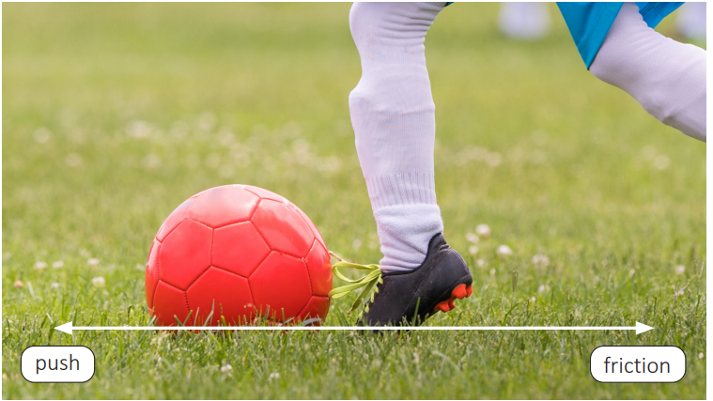 | 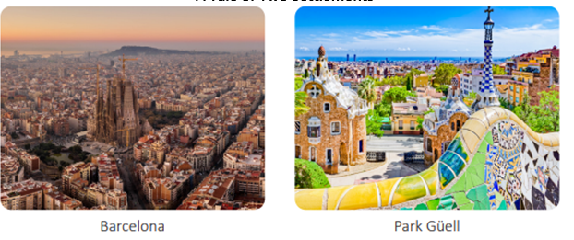 | Use an Ordnance Survey map to go for a walk. What did you find useful? Take a video of your experiences and send it in.  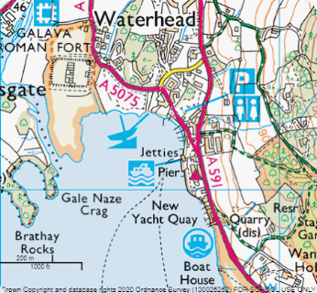
Design Challenge  Design a moving toy using a mechanism such as a lever, slider or wheel and axle. Label your design and explain how it works. | Vocabulary Collector – Find ten unfamiliar words. Write their meanings and use each in a new sentence. | Map Challenge – Draw a map of two settlements. Label key features such as roads, schools, parks, rivers and shops. Which settlement would you rather live in? Explain why.
Reading  Retrieval Challenge  Read for 20 minutes. Write five retrieval questions and answer them. | Are you enjoying your book? Why/why not? Write a book review – remember to include your recommendations for the book. | ➗ Maths  . Times Tables – Practise all multiplication facts to 12 × 12. Then solve 20 mixed multiplication and division questions.

