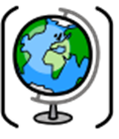
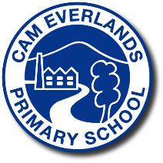
Endpoints for Geography
Year 1 – Local Explorers

We will learn about what geography is and how it helps the world around us. We will also be finding out about physical and human features and looking at simple maps.

What I know and can explain
Human features have been made by people and include houses, bridges and roads
Physical features are made by nature. They include hills, mountains, beaches and oceans
A map is a picture or drawing of an area of land or sea that can show human and physical feature
A location is a place or position of something
Direction is the way you travel to get somewhere.

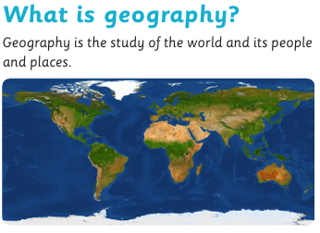

Useful Vocabulary
Atlas - A book of maps
Coastline – The place where the land meets the sea
Compass – A tool which helps us find a direction
Hill – A raised area of land, smaller than a mountain
River – A flow of water across the land, usually into the sea.
Settlement - A place where people live and work

