DT  Plan and help cook a healthy meal with your grown up. Take pictures and write an evaluation of your meal. | PSHE  Sign up to the My Happy Mind App by scanning this QR code: | Computing  Make a paper keyboard and practise your touch typing skills. Play Dance Mat Typing Game on BBC Bitesize website. | Science  Put on a shadow show (cardboard puppets or hands + torch). Email videos or pictures to Mme Brunet.
English  Remember to read 5 times per week.  Login on EdShed & Rollama for weekly activities. | 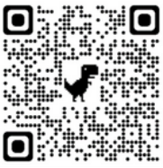  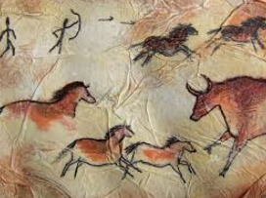  Year 3  Terms 1 & 2  Homework Grid |  | Maths  Practise your time tables (2, 5, 10) and numbers bonds to 10, 20 and 100.
Geography  Choose somewhere outside and draw a sketch map of what you see, including a key with symbols for different land uses (ie car for roads, little house for residential). | History  Produce cave art with different mediums. You can try and use fallen leaves from the trees as paint brushes, crush berries for your paint like they would have done at the time. | Music  Find the pulse in songs you listen to at home. How many different ways can you find of showing the pulse? Head nods, finger tapping, hand clapping etc. | RE  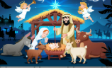  Write a poem about what you love most at Christmas time and illustrate it.

