DT  Plan and help cook a healthy meal with your grown up. Take pictures and write an evaluation of your meal. | PSHE  Sign up to the My Happy Mind App by scanning this QR code: | Computing  Make a presentation about your favourite hobby. Why do you like it? How did you learn it? | 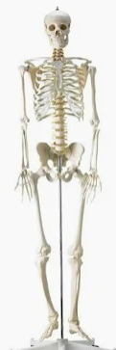  Science  Make a model of a human skeleton in a creative way – play dough, paper straws, Legos… anything!
English  Remember to read 5 times per week.  Login on EdShed & Rollama for weekly activities. | 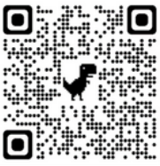  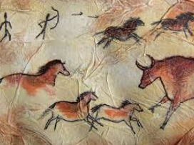  Year 3  Terms 1 & 2  Homework Grid |  | Maths  Practise your time tables (2, 5, 10) and numbers bonds to 10, 20 and 100.
Geography  Make a collage of features of a European country or a UK city.  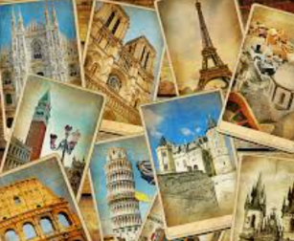 | History  Produce cave art with different mediums. You can try and use fallen leaves from the trees as paint brushes, crush berries for your paint like they would have done at the time. | Music  Find the pulse in songs you listen to at home. How many different ways can you find of showing the pulse? Head nods, finger tapping, hand clapping etc. | RE  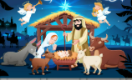  Write a poem about what you love most at Christmas time and illustrate it.

