DT  Can you design a vehicle to escape a volcano eruption as fast as possible? Think wheels and axles. | PSHE  Gratitude Journal:  For a whole week, write one thing you are grateful for each day. | Computing  Find the email section in purple mash and send an email to Mme Brunet explaining what you like and don’t like about being in year 3. | Science  Design a poster for the classroom to remind everyone of the different animal diets (carnivores, herbivores…).
English  Remember to read 5 times per week.  Login on EdShed & Rollama for weekly activities. | 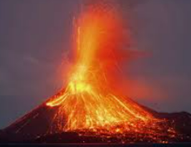    Year 3  Terms 3 & 4      Homework Grid |  | Maths  Subitising games: how fast can you show a number with your fingers?
Geography  Make a model of planet Earth showing the different continent names. Be creative: use recycling material, bake, paint, draw… | PE  Learn a dance routine or make your own and practise so you are ready to demonstrate to the class. | Music  Choose your favourite tune and change the words to sing about the times table(s) you are focussing on at the moment. | RE  Write the Easter story in your own words and/or illustrate it with the material of your choice (collage, colouring pencils, watercolours, etc)

